Award Portal User Guide

Insert TOC

General Layout:
Log into AwardPortal using uwnetid https://fin-s-web22.finance.uw.edu/fin/AwardPortal/
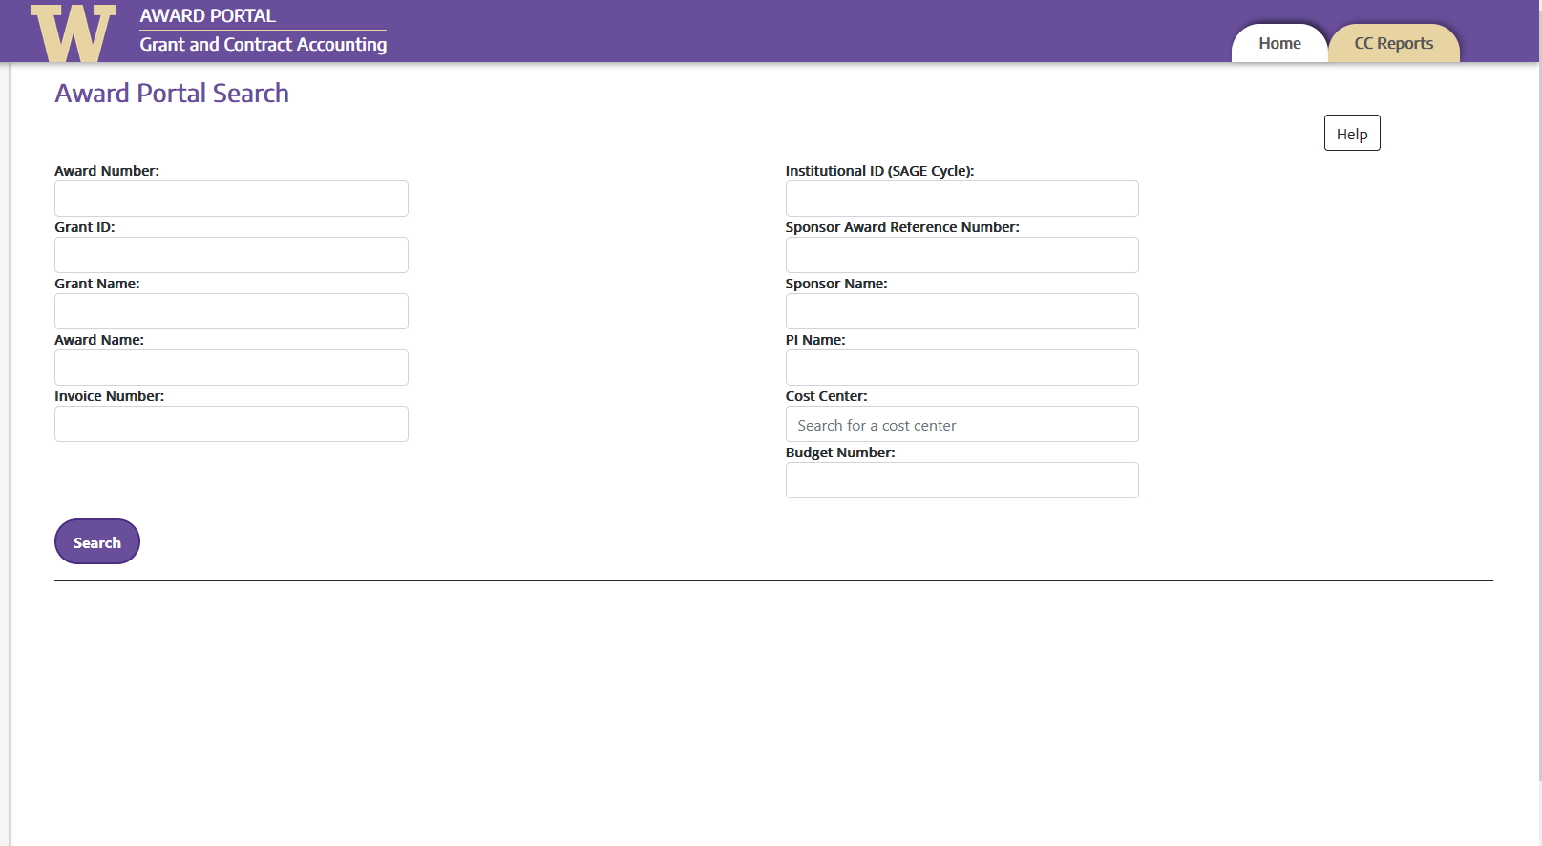
You can search by:
Award Number: AWD-######
Grant ID: GR######
Grant Name
Award Name
Invoice Number
Sponsor Name
PI Name
Cost Center
NOTE: you must include the prefix to search, ie AWD- or GR
Ex: “GR012345” or “AWD-123456”

If you search by AWD number, then the search results will display below the search bars in 4 sections

Award Information
This is where the following items are shown:
Award lifecycle
total periods
federal grant ID (if applicable)
Sponsor
Cost Center
Purpose code
eGC1 #
Cumulative Financial Info

Award Line Financial Information
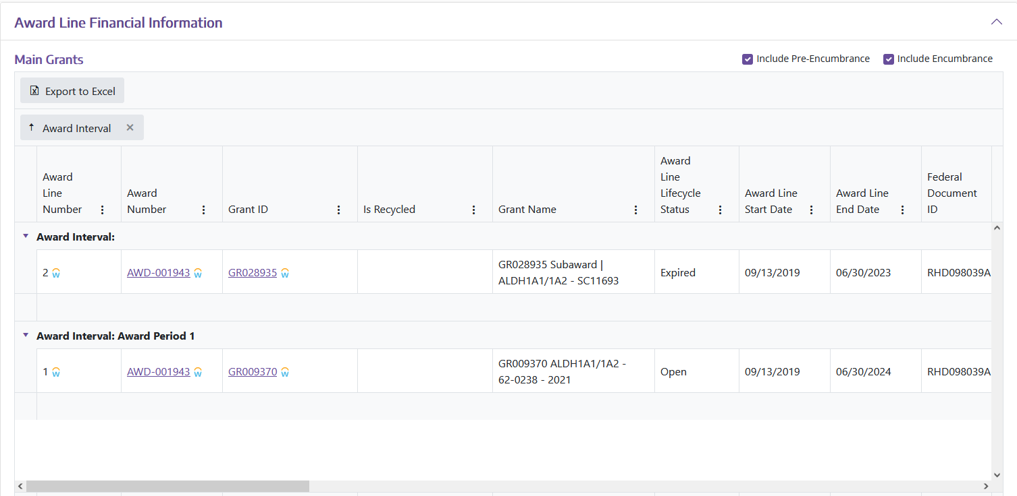

Open tickets
Any open tickets or past tickets for the grant are listed here.
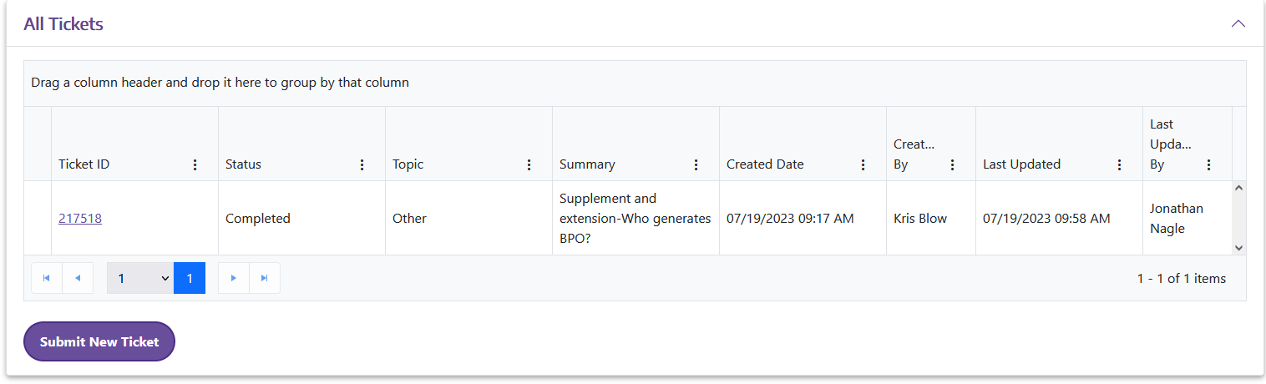
Tickets section is where you submit grant worktag specific questions, requests, issues-Basically anything that GCA handles

Possible tickets include:
Updating Grant Managers (NOTE: this is post award fiscal compliance, not the Workday security roles)
Requesting closure of a budget
Questions on how to handle an issue for a grant
Requesting Info correction on Award/Grant Info pages

Open Tasks
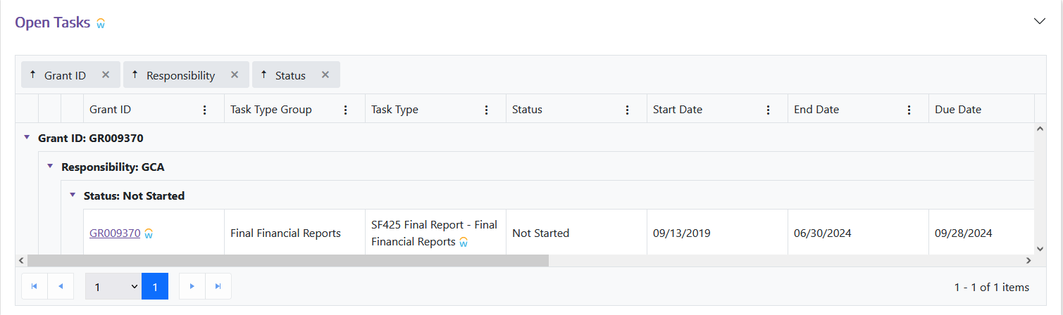
This section shows any action items for the award or grant, which can be items the lab are responsible for (RPPRs) or GCA specific Items (financial reports).

If you search by an AWD ID, then it will show all grants under that award. This is helpful for multiyear grants, since each year gets a new GR #.

If you search by Grant ID, there are a few more sections that will appear:

Grant Information
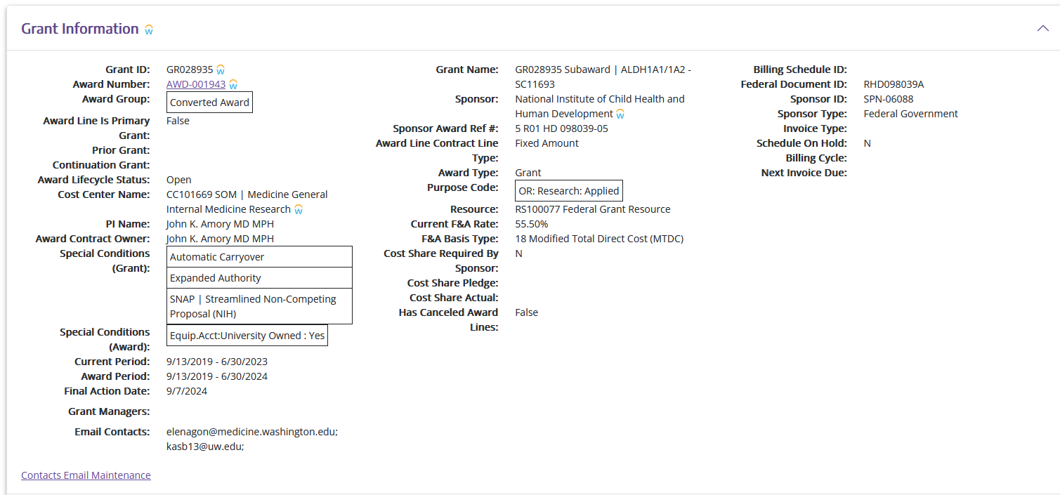
Always check this for your awards!!
For example, this one does not list grant managers, so we would submit a ticket to update that.
Grant Information tab shows additional information on top of the Award Info tab, such as whether automatic carryover is permitted, if cost share exists, final action date for that grant line, grant managers, and grant email contacts

Updating Grant Contacts
This is where you manage the grant contact emails. Click the “Contacts Email Maintenance”
This loads a new page where there is a text box.

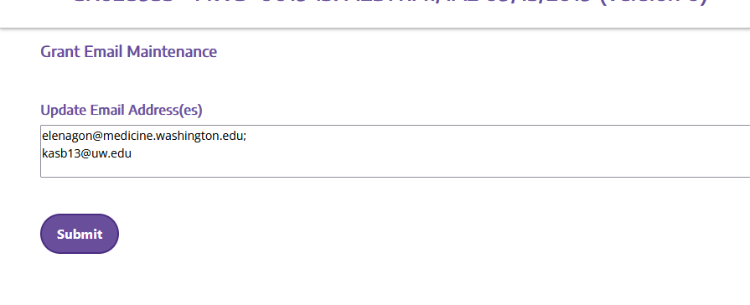
Simply enter the new contact email address, delete old ones, etc and click Submit

Any subawards for a grant line item appear as separate line items, with a unique GR #

Invoices
All invoices that have been sent by GCA for the grant line and award period show up here

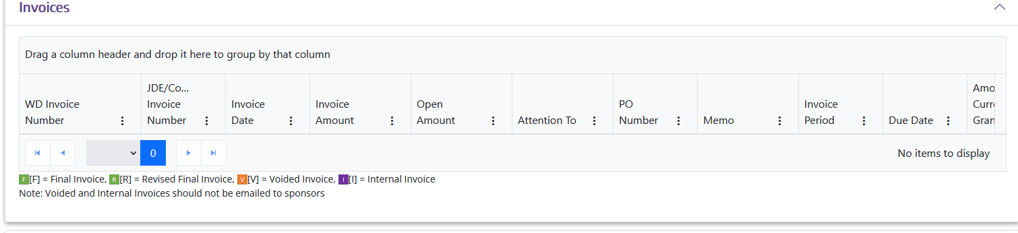

Receipts
Any receipts for paid invoices or money sent for the grant period show here.

