Gift Processing Forms

New Endowment Allocation
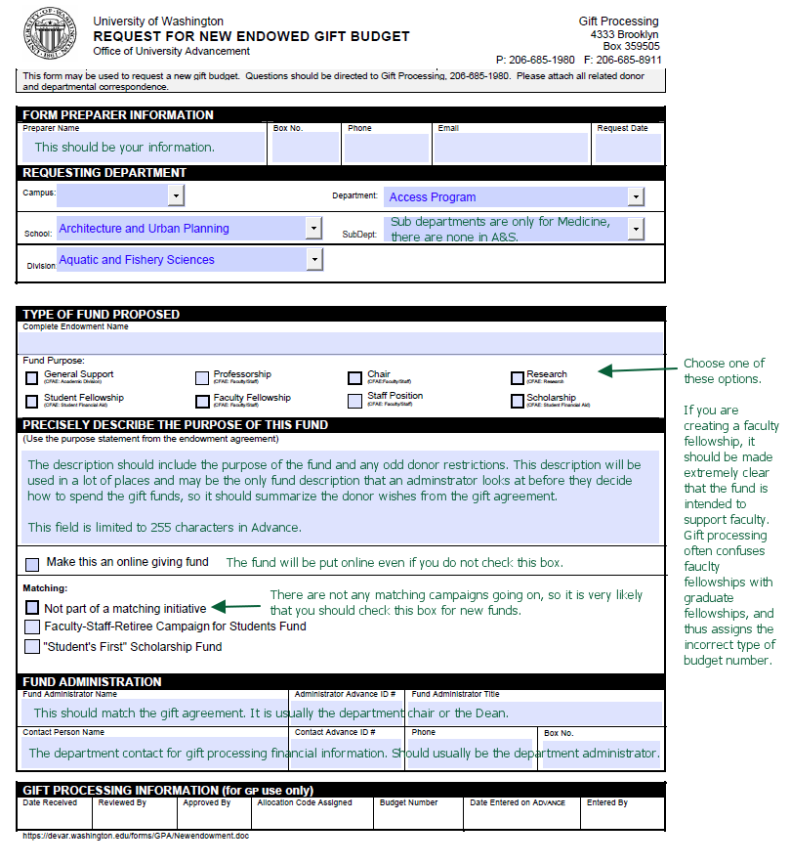

New Current Use Allocation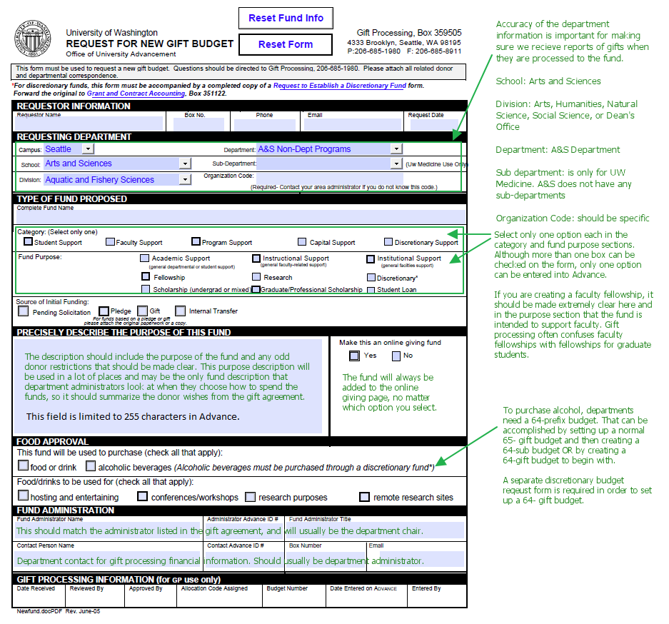

New Discretionary Budget
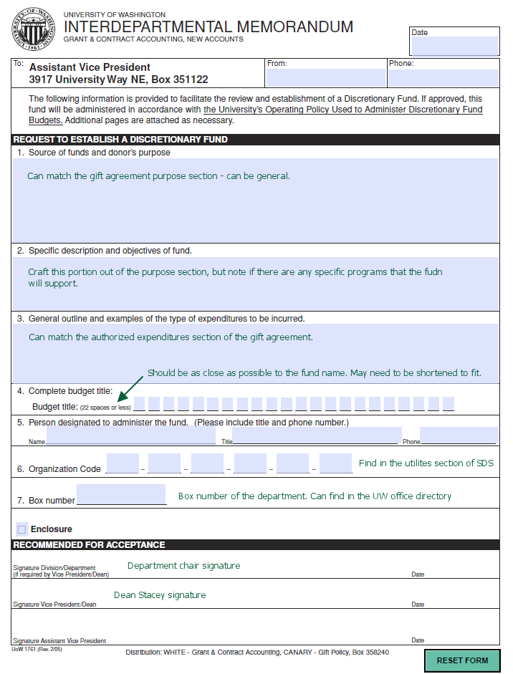

Pledge Form
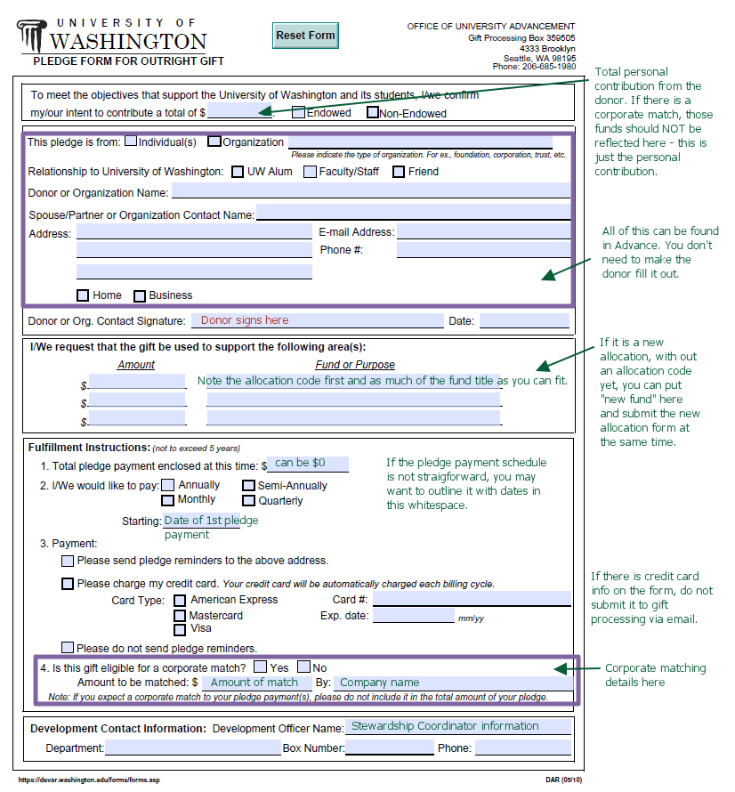

Gift Transmittal – for an individual. There is a different form for organizations, but that is used less frequently. This form does not need to be seen or signed by the donor.
