SIGNING A GIFT AGREEMENT

VIA DOCUSIGN



**Step 1. Review the DocuSign email from Donor Services.**

Open the email and review the message from Donor Services. Click “view documents” to begin the signing process.

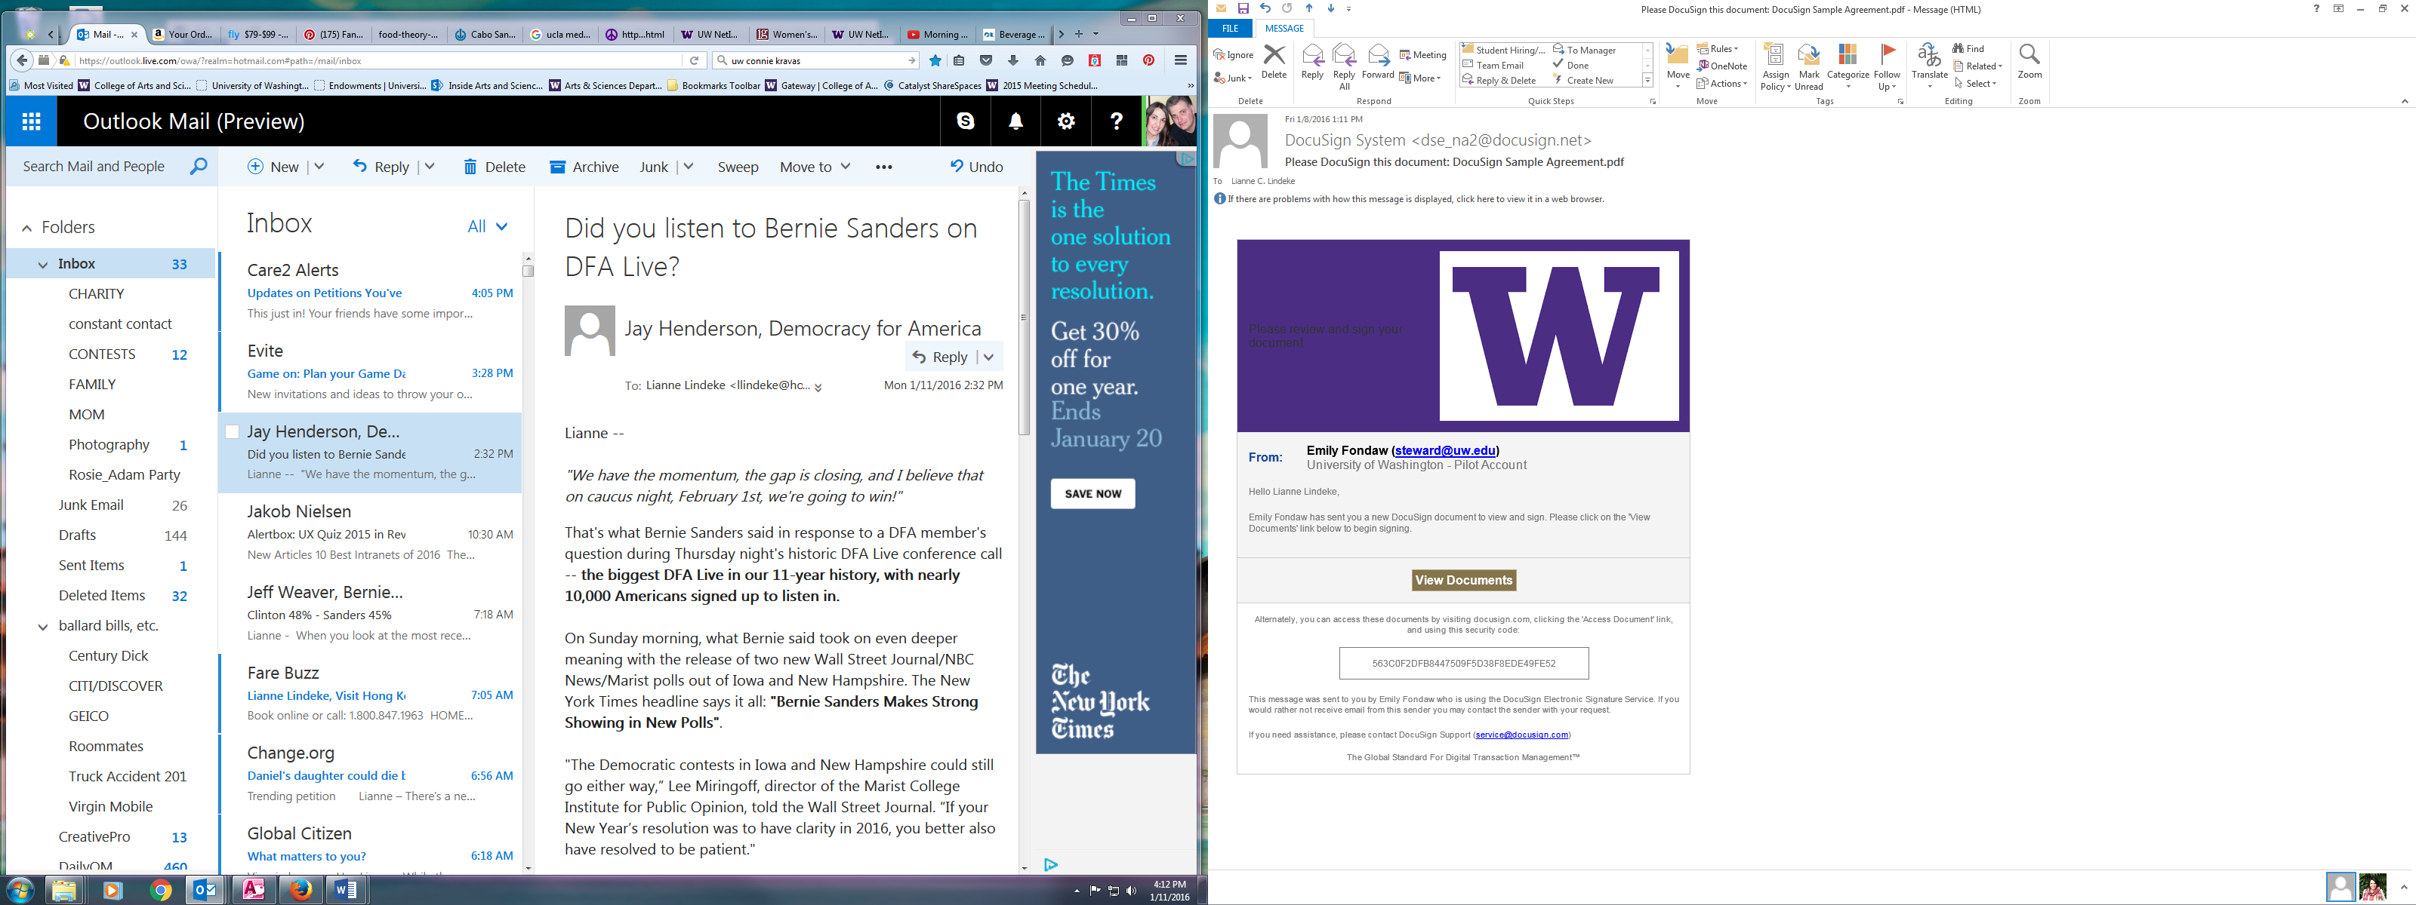

**Step 2. Accept electronic signing.**

Check the box and click “continue” to accept using electronic signatures.



**Step 3. Review the document.**

Read through the document to review it.

**Step 4. Start the signing process.**

Click the start tag on the left to begin the signing process. You are taken to the first tag requiring your action. Click the sign here tag.

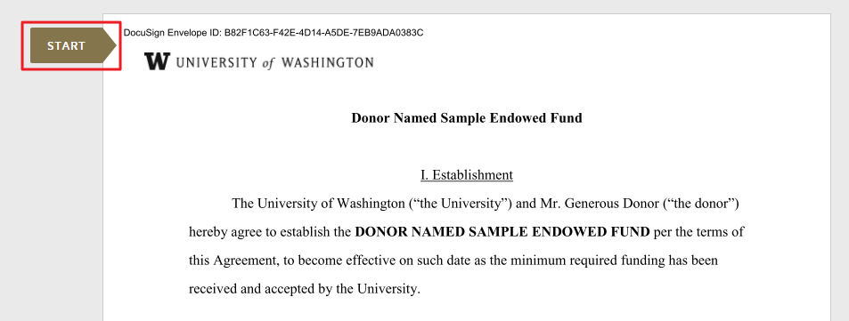

You are taken to the first tag requiring your action. Click the sign here tag.

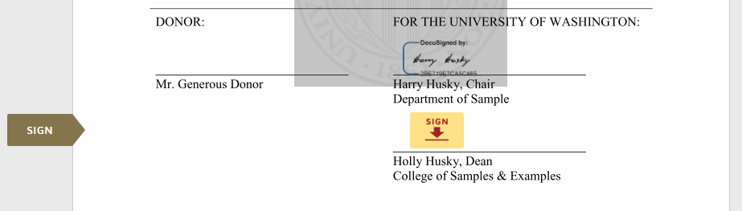

**Step 5. Adopt your signature.**

Verify your name, and choose how you’d like to sign. Do one of the following: accept the default signature and initial style, click change style and select a different signature, or click “draw” to sign with your mouse or finger on a touchpad.

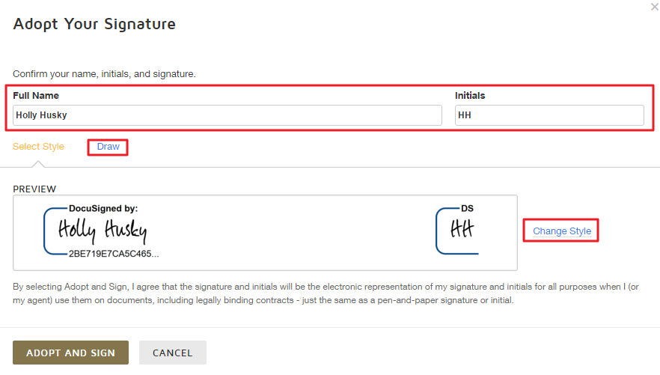

**Step 6. Save your signature.**

Click “adopt and sign” to save your signature information and return to the document.

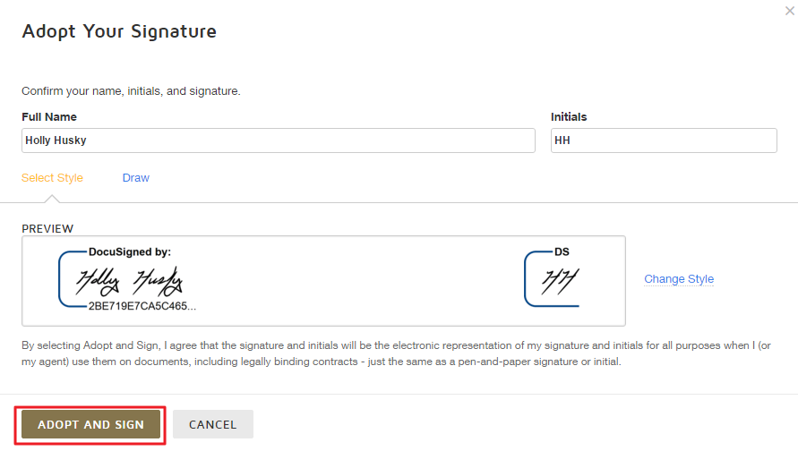

**Step 7. Confirm the signing.**

When you finish clicking all of the signature tags in the document, the “confirm signing” tag appears. Click “confirm signing” to finish with the document. A message appears stating that you have completed your document.

