Vanity URLs for Online Gift Funds

Go to https://www.washington.edu/cms/giving/short-url-request-form/

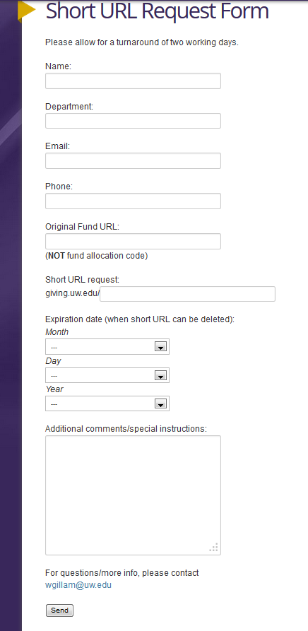
This field can be anything you or the fundraiser wants. For example, if you were fundraising for the Center for Conservation Biology Support Fund, you could request the vanity link to be giving.uw.edu/conservation.
You will need to know the allocation code of the fund in order to complete this field.

To link to the fund in the browsing section use: https://www.washington.edu/giving/make-a-gift/?page=funds&source_typ=3&source=ALLOCATIONCODE

To link to the fund already in the cart use: https://www.washington.edu/giving/make-a-gift/?page=make&code=ALLOCATIONCODE

