CONFIDENTIAL BRIEFING PAPER
EVENT TITLE (EX: TIMELESS AWARDS)

PREPARED FOR: TITLE, NAME

Location:
Address:
Phone Number:
Donor Address/Location (if applicable): Date: 00/00/00
Time: 0:00 – 0:00

VENUE DETAILS

Special Instrutions:
Parking:
ADA Accessibility:
Unqiue Features:

IMPORTANT CELL PHONE NUMBERS

Donor/Volunteer Name (206) xxx-xxxx
Bob Stacey (206) xxx-xxxx

Tracy Ostrem (206) xxx-xxxx

*include all CAS Dean’s office attendess Number

Name Number

ATTENDEES
Name Name

EVENT SCHEDULE

0:00 PM | Reception begins
0:00 PM | Info
0:00 PM | Info
0:00 PM | Info
0:00 PM | Closing Note

YOUR ROLE
Describe their role at the event. Example: As a representative of Arts & Sciences, you are a key member of the stew- ardship team at this event. This is a recognition event to our donors.

EVENT DETAILS AND BACKGROUND
Describe their role at the event. Example: As a representative of Arts & Sciences, you are a key member of the stew- ardship team at this event. This is a recognition event to our donors.

Arrive at:
Parking:
Attire:

SPEAKING POINTS
Include any speaking points for the attendee where applicable

NAME

UW Affiliation: Alumnus or Friend, Board Affiliations, Faculty, Former Staff etc. (Example. BA 1973 College of Arts & Sciences (Major: History), Henry Suzzallo Society, UW Foundation Board Member)

UW Giving History: Capacity (Example: E - $5M-$9.9M)
Top Giving Areas: (Example- can pull this information in ReportWriter using “Capture”)

UW Medicine
Intercollegiate Athletics
$ Amount
$ Amount

Foster School of Business $ Amount

Total UW Giving: Relationship Manager:
Endowments:

Open Ask: (Current Proposal Asks)

Include a bio about the donor which can be found under Prospect Notes in Advance, but additional research may be necessary. This area describes the donor’s background, career information, interests and involvement in the UW and community.
List any endowments and related information, for example the description, holder of the endowment if applicable, their term start and end dates, and research interest.

CONTACT INFORMATION

First Last Name
Position Title, Explanation email@uw.edu
(206) 123–4567

**Convert the final version into a PDF. There may be extra information to also convert into a PDF and attached to the final briefing PDF document: driving directions, parking information and event invitations etc.

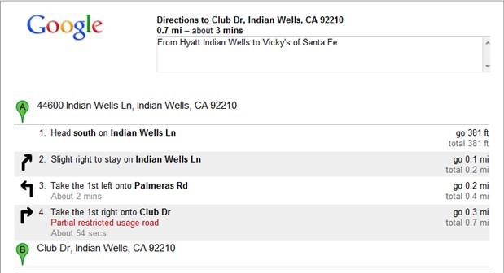

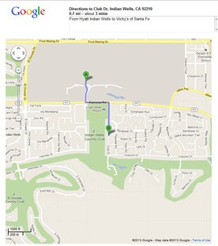
*Include driving directions and a map

