CONFIDENTIAL BRIEFING PAPER
EVENT TITLE (EX: DINNER WITH DUB & DONOR)

PREPARED FOR: TITLE, NAME

Location:
Address:
Phone Number:

VENUE DETAILS
Donor Address (if applicable) Parking:
ADA Accessibility:
Date:
Time:

IMPORTANT CELL PHONE NUMBERS

Donor/Volunteer Name (206) xxx-xxxx
Bob Stacey (206) xxx-xxxx

Tracy Ostrem (206) xxx-xxxx

*include all CAS Dean’s office attendess Number

Name Number

ATTENDEES
Name Name Name

TIMING
Arrive at 0:00

PARKING
Example- Valet parking is available at 5th Avenue entrance

ATTIRE
Information

STRATEGY
Identify what we are trying to learn from the meeting.

GOALS
Describe the goals for the meeting.

CONVERSATION TOPICS
Why are we having this conversation? Include any speaking points, questions or updates for the guest

NAME

UW Affiliation: Alumnus or Friend, Board Affiliations, Faculty, Former Staff etc. (Example. BA 1973 College of Arts & Sciences (Major: History), Henry Suzzallo Society, UW Foundation Board Member)

UW Giving History: Capacity (Example: E - $5M-$9.9M)
Top Giving Areas: (Example- can pull this information in ReportWriter using “Capture”)

UW Medicine
Intercollegiate Athletics
$ Amount
$ Amount

Foster School of Business $ Amount

Total UW Giving: Relationship Manager:
Endowments:

Open Ask: (Current Proposal Asks)

Include a bio about the donor which can be found under Prospect Notes in Advance, but additional research may be necessary. This area describes the donor’s background, career information, interests and involvement in the UW and community.
List any endowments and related information, for example the description, holder of the endowment if applicable,
their term start and end dates, and research interest.

CONTACT INFORMATION

First Last Name
Position Title, Explanation email@uw.edu
(206) 123–4567

**Convert the final version into a PDF. There may be extra information to also convert into a PDF and attached to the final briefing PDF document: driving directions, parking information and event invitations etc.

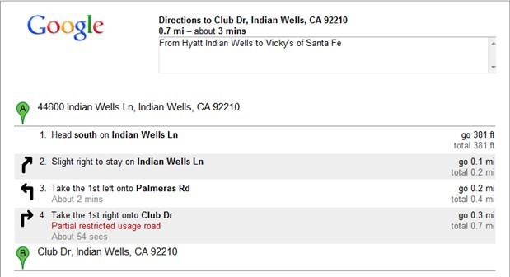

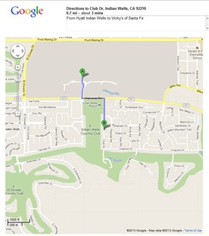
*Include driving directions and a map

