Sample Beneficiary Portal Messages to Students

The deadline should be updated every year. Brackets indicate merge fields available in Beneficiary Portal. For example, [Click Here] is a link that is unique to each student, and will be automatically inserted when you send your message. A sample email is included below.

Manage Your Messages
BCC me on all emails

Initial Email Body
Dear [Bene Name],

Your scholarship, the [Award] was made possible through the generosity of our donors, who believe in supporting the academic goals of students like you.

Before the academic year comes to an end, we ask that you thank the people who established this scholarship by expressing your appreciation and describing what their support has meant to you.

Please [Click Here] to visit our online tool, which will allow you to tell the donors about yourself and your life at the UW College of Arts and Sciences. Take your time and craft a thoughtful narrative that touches on your recent educational highlights and ties them to the support you received from this award.

Please submit your thank you letter by March 31, 2019. Sample letters can be found here. Congratulations on receiving this award! If you have any questions, please feel free to reply to this email at CASadser@uw.edu.

Sincerely,
Becky McIntire
Donor Services Specialist
College of Arts and Sciences

UW Campus Box 354882, Seattle, WA 98195
phone 206.685-2606 / CASadser@uw.edu

Reminder Email Body
Dear [Bene Name],

This is a reminder to submit your statement of thanks to the donor of the following: [Award]. Please let the donor know the impact of their gift on you and your academic success.

Your participation in thanking our donors and letting them know the impact this award had is vital. Please [Click Here] to submit your response as soon as possible.

If you have any questions about this request, please do not hesitate to reply to this email.

Sincerely,
Becky McIntire
Donor Services Specialist
College of Arts and Sciences

UW Campus Box 354882, Seattle, WA 98195
phone 206.685-2606 / CASadser@uw.edu

Returned Email Body
Dear [Bene Name],

I've reviewed your message to the donors and would very much appreciate if you would take additional time to revise your personal statement. Please remember that your award would not be possible without the generous support of our donors. Just [Click Here] to revise your statement. The notes on the right side of the page may be used to help guide your responses.

Sincerely,
Becky McIntire
Donor Services Specialist
College of Arts and Sciences

UW Campus Box 354882, Seattle, WA 98195
phone 206.685-2606 / CASadser@uw.edu

Approval Email Body
Dear [Bene Name],

Thank you so much for telling the donors of the following awards about yourself and your UW College of Arts and Sciences experience as the recipient of the [award].

They will be thrilled to know that their investment in the UW, and in you, was so worthwhile.

I wish you much success both on and off-campus!

Sincerely,
Becky McIntire
Donor Services Specialist
College of Arts and Sciences

UW Campus Box 354882, Seattle, WA 98195
phone 206.685-2606 / CASadser@uw.edu

Beneficiary Instructions
Below, we are asking you to express your appreciation to the donors and to tell them a little about yourself with a minimum of 300 words.

Our goal is to show donors the impact of their giving through you, so don't hold back. Say thank you and share a little about yourself, and what the scholarship has meant to you. You can tell them:

- why you chose the UW
- why you love your College of Arts and Sciences major(s)
- favorite or transformational classes and/or professors
- milestones reached
- awards you've earned
- challenges you've overcome
- your future plans

Whenever possible connect their support to your success. Feel free to upload links to an online portfolio and examples of projects/experiences you're particularly proud of. While the online tool uses your UW Husky card photo, you may replace it with a favorite photo of yourself.

Please also consider the following background story of the fund(s) as it may help you to make a personal connection with the donors.

[story]

Updating your Fund Stories

The [story] link above is one of the automatically updated merge fields in Beneficiary Portal. But for it to work, you will need to ensure that your scholarships have Fund Stories attached.

To do this, when you are logged into Beneficiary Portal, go to the upper right hand corner and click ADMINISTRATION/Manage Your Fund Stories.

You should see a list of funds, and any missing ones will need to be requested from Donor Relations at donorsvc@uw.edu.

Click Edit. The Edit Fund Story window opens. To upload the Fund Story from Advance, click the icon on the far left.
(Pictured below.) You might need to shorten the story, or expand on it if any additional details are known.

This is also a good place to add information about the current stewardees, and how the student should best address them in their letter. In some cases, it might also be helpful to tell the students whether they are addressing a donor, next of kin, honoree, etc.

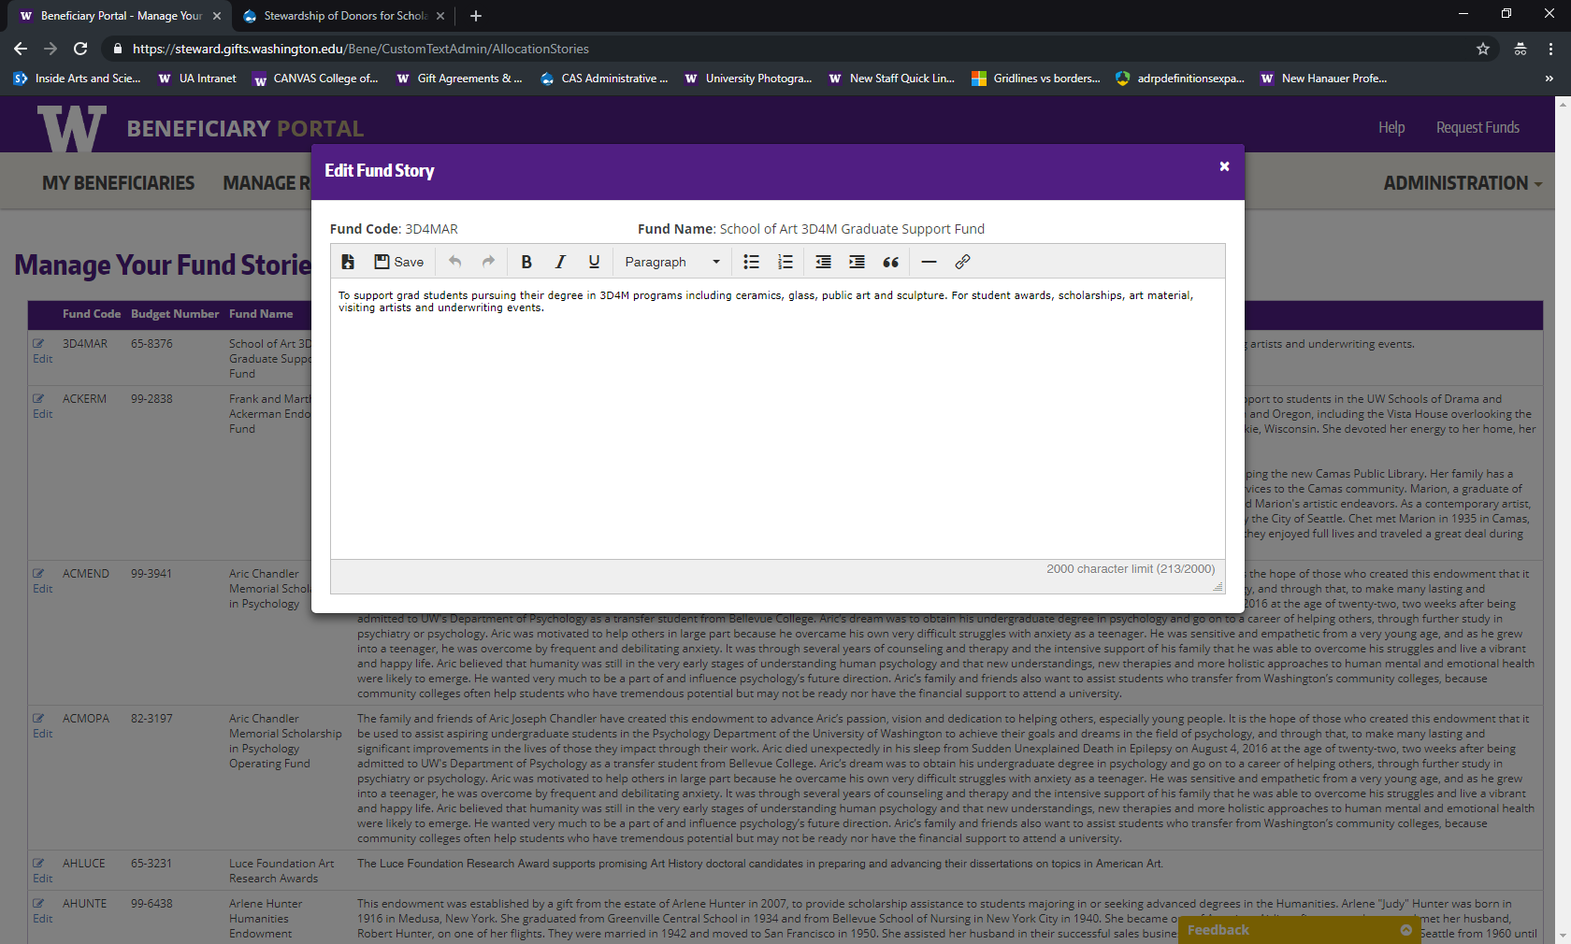

Sample Beneficiary Portal Email to Student

From: College of Arts & Sciences <donrsvrs@uw.edu>
Sent: Thursday, March 7, 2019 10:08 AM
To: lmeagles
Subject: Míceál F. Vaughan Endowed Fund for Textual and Manuscript Studies Personal Statement Request

Dear LANE M EAGLES,
Your scholarship, the
- Míceál F. Vaughan Endowed Fund for Textual and Manuscript Studies
was made possible through the generosity of our donors, who believe in supporting the academic goals of students like you. To fully thank and honor our donors, we are committed to connecting them to our scholarship recipients.
Before the academic year comes to an end, we ask that you take some time to thank the people who established this scholarship by expressing your appreciation and describing what their support has meant to you.
Please click here to visit our online tool, which will allow you to tell the donors about yourself and your life at the UW College of Arts and Sciences. Take your time and craft a thoughtful narrative that touches on your recent educational highlights and ties them to the support you received from this award.
Please submit your thank you letter by Sunday, March 31, 2019. Examples of past letters can be found here. Congratulations on receiving this award! If you have any questions, please feel free to reply to this email at CASadser@uw.edu.
Sincerely,
Becky McIntire
Donor Services Specialist
College of Arts and Sciences
UW Campus Box 354882, Seattle, WA 98195
phone 206.685-2606 / CASadser@uw.edu

