(DONOR) BRIEF

EVENT TITLE (EX: DINNER WITH DUBS & DONOR)

DATE

TIME

LOCATION
[Location] is located on the [floor] in the [building name] at the UW Campus. [Event lead] will meet you a few minutes before [time] in the [lobby/etc] and walk with you to the meeting.

Should you get lost, or have any questions, [event lead]’s cell phone is: [cell phone #]

Campus Map: http://www.washington.edu/maps/
College of Arts & Sciences Office Phone: (206) 543-2888

PARKING
Parking has been reserved for you in the [garage/lot name] (circled in red below).
- Please enter through any of the gatehouses on campus.
- Advise the Parking Specialist that you have a parking code - "######"
  - If you need disability accommodations please advise the Parking Specialist.
- Park in the [garage/lot name].
- Display your permit face up and visible on your dash. Vehicles are subject to a citation if a permit is not visibly displayed.

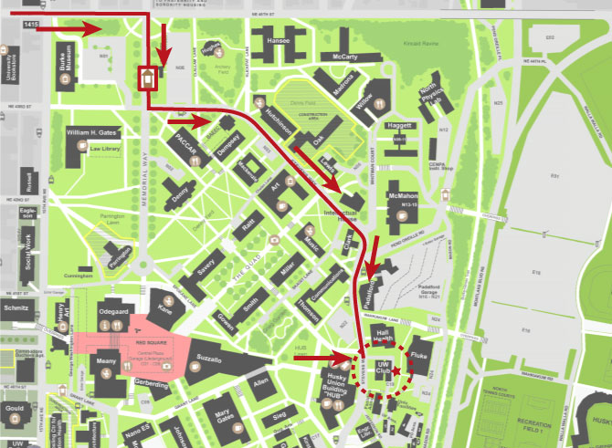

AGENDA

0:00 PM | Your arrival
0:00 PM | Reception begins
0:00 PM | Info
0:00 PM | Closing Note

ANNOTATED GUEST LIST
First Last Name  Title, Organization  Pronouns, if applicable | Short biography about this person highlighting their purpose at this event and potential conversation topics. | 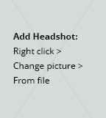
First Last Name  Title, Organization  Pronouns, if applicable | Short biography about this person highlighting their purpose at this event and potential conversation topics.
First Last Name  Title, Organization  Pronouns, if applicable | Short biography about this person highlighting their purpose at this event and potential conversation topics.

PREPARED BY

First Last Name
Title
College of Arts and Sciences
@uw.edu| (206) ###-####

