USING NAME TENT AND NAME BADGE TEMPLATES
GUIDE TO SPECIAL FORMATTING TRICKS IN WORD FOR AVERY TEMPLATES

- Open the template that corresponds to the Avery templates that you plan to use. Note that name of the file lists “AVERY ####” which tells you which template it’s formatted to.

- Select Enable Editing

- Determine if you will be using job titles, or only first and last names.

- If you do not need the title field, it’s best to remove it before you begin your mail merge. Remove the Title field:
  - Navigate to the Mailings tab
  - Move your curser to just after the g in “Executive Dog” and hit Backspace twice. This will delete the whole field without removing formatted spaces.
  - Click “Update Labels” – You will now see that the First Name and Last Name fields. Do not worry about the formatting in this view. This will go away when you begin your mail merge.

- To Mail Merge:
  - In the Mailings tab, choose Select Recipients and then Use an existing list
  - When importing, make sure to select the box that indicates the top row has headers.
  - Once you hit OK, you should see the Word document filled in. If you still see the First Name and Last Name fields, select Preview Results

- To finalize your template:
  - In the Mailings tab, select Finish & Merge
  - Choose Edit Individual Documents
  - You will be asked if you are exporting all or some of the documents – choose what is necessary for your needs (usually “All”).
  - Note that this will open a new document that is no longer mail merged. If you need to make changes to the mail merge, you will want to make edits and save from the previous merge document.

- Make sure to save your new document somewhere so you can access it later.
  - From here you can print, save as PDF, or follow a different process that you would normally do.
  - Follow the instructions on the Avery template box to ensure paper is loaded correctly in your printer tray.
  - Print to your printer’s bypass tray, and you’re good to go!

TROUBLESHOOTING: Avery 5302 Small Tent Cards
- After importing your list, select the Preview Results button to see the field formatting.
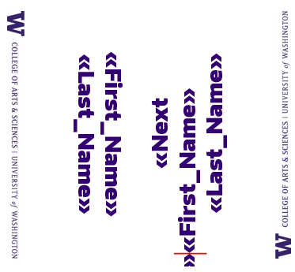
- On the second cell of the first template, place your cursor in between the two arrows next to First Name and hit backspace twice. This will remove the prompt for Word to find the Next Record.

- Select Preview results again and your first two cells should be the same name now.

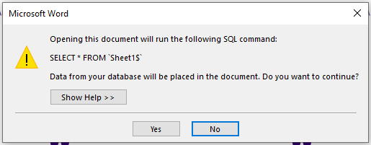
TROUBLESHOOTING: Error for lost database when opening template

- Select “No” which should bring you to the template.
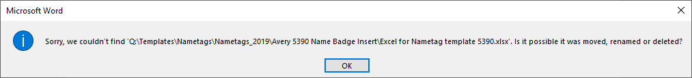
- If you get more prompts, click through Yes/OK until the dialogue boxes go away, or until you get a prompt to Cancel.
- On the Mailings tab, your Write & Insert Fields ribbon will be greyed out, however you can still edit the fields shown by deleting or backspacing unwanted fields.
- You can then begin your Mail Merge (Step 5 on previous page)

