Workday report R1252 (Expendable Gift Activity Summary with Balance)
Last updated 2025.02.14 by Advancement Services (casadser@uw.edu)
This focuses on your expendable gift resource dollars, by GF gift worktag. By filtering with your cost center hierarchy, this report will let you quickly see current balances, expenses/revenue, and encumbrances. Note that the R1252.1 (extract version) includes additional fields such as basic high-level descriptions/restrictions, which can easily be exported into Excel.

Technical details:
- This filters on your “Gift and Endowment Resources” resource hierarchy (RSH 03) dollars
- It excludes endowment principal dollars (RS100204) from consideration.

Additional note (uncommon):
For some impacted units, this report will also show gift resource dollars that are missing GF worktags. These dollars will show up towards the bottom of the list with “(blank)” GF worktags, and they will usually carry resources RS100375 or RS100376, as well as Fund worktag FD214. Please note that in the majority of cases, these are dollars that carried-forward (FY23 to FY24) from pre-Workday budget numbers that lost their associations with their respective gift funds. Please contact Advancement Services if you have questions about these. We can help determine what the correct restrictions for these are; they are not necessarily unrestricted gift dollars.

Initial filters:
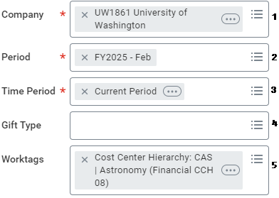
The typical filters you might use:
- Company: for CAS, this will be “UW1861…”
- Period: the latest month, unless you’re looking for a snapshot of a previous date.
- Time Period: “Current Period” will capture the latest balance and encumbrance info, as well as expense/revenue transactions in the current month. Current Year is another good option if you’re looking at activity for this FY.
  - If you’re hoping to additionally include transactions that straddle multiple FY’s, you could also use “Last 36 Periods” (i.e. last 36 months).
- Gift Type: Can usually be left blank, unless you want to filter by current-use vs. endowments.
- Worktags: Almost always your CC cost center or CCH cost center hierarchy at minimum.
  - You can take advantage of the auto-fill by starting to type “CCH 08” and then your unit name. If attempting to search at higher or lower levels in the hierarchy, adjust the CCH 0x accordingly.

Results Page
The first (left) section lists your balances by gift worktags. This will also show basic details in columns:
- Gift worktag
  - Right-click the worktag and open as a new tab to see more details. The Overview>Restriction tab provides a “Restriction Description” noting a high-level description. In some cases (usually endowments), you’ll also find an entry in the “Nature of Restriction” field, noting a more detailed description. If you have questions/concerns about these, reach out to Advancement Services (casadser@uw.edu) for any clarification or requested updates.
- Gift default cost center
  - Note that this may show other units, if the gift fund’s primary administering unit is a different unit. This often comes into play when another unit transfers money to your cost center while retaining the original gift worktag
- Gift established date: typically when the gift fund record became active
- Gift type: while this breaks down endowments into additional types, you can generally view these entries as either “Current-Use” or “Endowed”.
- Primary purpose: the general restriction type of the fund. Note that you should always understand the actual restrictions and parameters of the fund.
- Fair market value (FMV): in the case of endowments, this notes the latest valuation of the endowment principal. Note that while this shows an “as of” date that may indicate today, this valuation is only conducted once a quarter, and can be as delayed as up to five months. For example, until the middle of Q4, the valuation will continue to reflect the beginning-of-Q3 calculation.
- Net book value: reflects the cost basis of contributions to endowment principals. As with the FMV calculation, this field is updated quarterly on a very delayed schedule.
- Endowment distributions in FYTD – reflects total endowment distributions to the expendable side of the gift worktag, for the FY of the month you set in the Period filter.
- FY beginning balance – reflects the beginning balance of the FY of the month you set in the Period filter.

The right section summarizes total transactions by month, as well as debits/credits and encumbrances. The farthest right column will show you your ending balances after encumbrances.

You can also drill-down on the “Ending Balance before Encumbrances” at the end, which will let you pivot all transactions within your time period. If you have further organized by PG program, AS assignee, or AC activity worktags, this is where you could pivot by those fields.
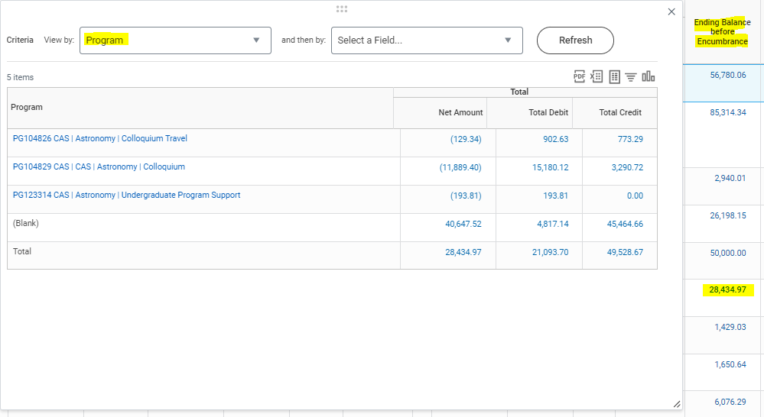

Note that the grand total field at the bottom of the “Ending Balance before Encumbrances” column is drill-able as well. This would let you pivot on all of your cost center’s gift dollars, using any desired fields (here we use Ledger Acct Summary LAS 05).
