Workday report R1300.5 (Actuals with Encumbrance Balance for Unit Reporting)
Last updated 2025.02.14 by Advancement Services (casadser@uw.edu)
This is a popular report with the CAS Dean’s Office. One of its main advantages is the ability to “repeat by” certain worktags as columns. If you’re looking into a specific gift worktag that you have organized by PG program or other worktags, you could repeat by those worktags to see activity subdivided by those worktags as columns.
R1300.5 does not inherently focus on gift worktags, but it can be adjusted to filter by gift activity for your listed gift or cost center hierarchy. Unlike R1252, this report can show revenue to your endowment principals, although please note that there are better resources <hyperlink> if your goal is to acknowledge/recognize gifts and donors to your endowments.

Technical details:
For gift activity, we recommend filtering by your “Gift and Endowment Resources” resource hierarchy (RSH 03) dollars, as well as excluding endowment principal dollars (RS100204) unless you’re specifically looking at your principals. Please remember that endowment principals indicate the cost basis, rather than fair market valuation. An endowment that was set up 20 years ago with $100k will have a significantly larger market value today, outputting much higher quarterly distributions than a new $100k endowment today.

Additional note (uncommon):
For some impacted units, this report will also show gift resource dollars that are missing GF worktags. You can identify these as any gift balances without associated GF gift worktags, or if they carry Fund worktag FD214 and Resource worktags RS100375/RS100376. Please note that in the majority of cases, these are dollars that carried-forward (FY23 to FY24) from pre-Workday budget numbers that lost their associations with their respective gift funds. Please contact Advancement Services if you have questions about these. We can help determine what the correct restrictions for these are; they are not necessarily unrestricted gift dollars.
Initial filters:
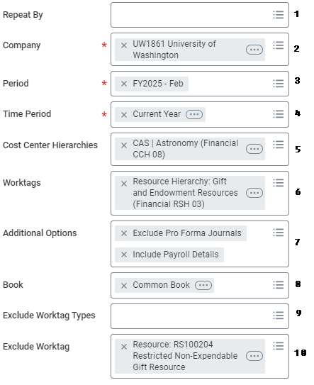

The typical filters you might use:
- Repeat by: you may leave this blank, or you can input program, resource, or other worktags if you know how you want to subdivide your report.
- Company: for CAS, this will be “UW1861…”
- Period: the latest month, unless you’re looking for a snapshot of a previous date.
- Time Period: “Current Year” will capture the latest balance and encumbrance info, as well as expense/revenue transactions in the current fiscal year.
  - If you’re hoping to capture transactions from prior FY’s, you could also use “Last 36 Periods” (i.e. last 36 months).
- Cost center hierarchies: input your CCH cost center hierarchy
  - You can take advantage of the auto-fill by starting to type “CCH 08” and then your unit name. If attempting to search at higher or lower levels in the hierarchy, adjust the CCH 0x accordingly.
- Worktags: to filter by gift resource activity, we recommend using the auto-fill to input “Gift and Endowment Resources” (RSH 03). Add any other GF gift or PG program worktags as desired.
- Additional options: leave as default
- Book: leave alone
- Exclude worktag types: leave alone
- Exclude worktags: exclude nonexpendable gift resource (RS100204) to exclude endowment principal revenue. Additionally exclude FD214 if you want to exclude gift dollars that have lost their associations with GF gift worktags.

Results Page
This report summarizes your expenses/revenue by ledger account hierarchies. Note that these round to the nearest dollar, so take care not to leave stray cents when you move money.
