REINVESTING ENDOWMENT EARNINGS

We encourage departments to use distributions per the donors’ intent. However, unspent endowment earnings can also be transferred back to the principle account to grow the corpus of the endowment for larger future distributions.
Unspent endowment earnings can be transferred back to the principle budget through MyFD with the following steps below:
- Log into MyFinancial Desktop, go to the TRANSACTIONS dropdown menu, and click on Journal Voucher.
- The data required in order get it processed is included below,
- Form Name/Description: Enter a short description of the transfer, like “reinvestment to 99-1234”;
- Explanation: Enter in a more detailed explanation here but mostly where the funds are coming from and moving to as well as the reason why;
- Approver UWNetID: Administrator or a person who can approve the transfer;
- Distribution List: Include the NetIDs of people who should be informed about the transaction;
- Document Attachments: Add backup documentation to this JV;

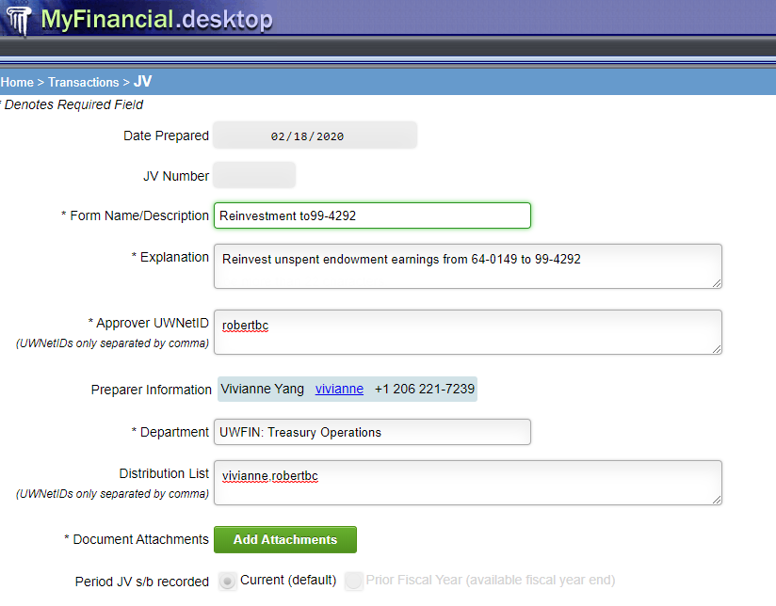

- In the JV Transactions Table (see example below), the top row is showing where funds are moved from.
- Description: Enter “from (budget name)”
- Fund or Budget Number: Enter the operating budget number where the funds will be moved from
- Obj Sub Ssub: Enter “948198” which is the revenue code for funds to “transfer out”
- Debit: Enter the amount that will be transferred
- Credit: leave this blank
- Task/Option/Project: only use this if your unit requires the use of these
h) The second row is used for the Endowment Suspense budget (969300) the funds are moved to.
- Description: Enter “to 96-9300”
- Fund or Budget Number: Enter 969300
- Obj Sub Ssub: Enter “948098” which is the revenue code for funds to “transfer in”
- Debit: leave this blank
- Credit: Enter the amount that will be transferred
- Project: Enter the 6 character allocation code for the endowment you are transferring funds into

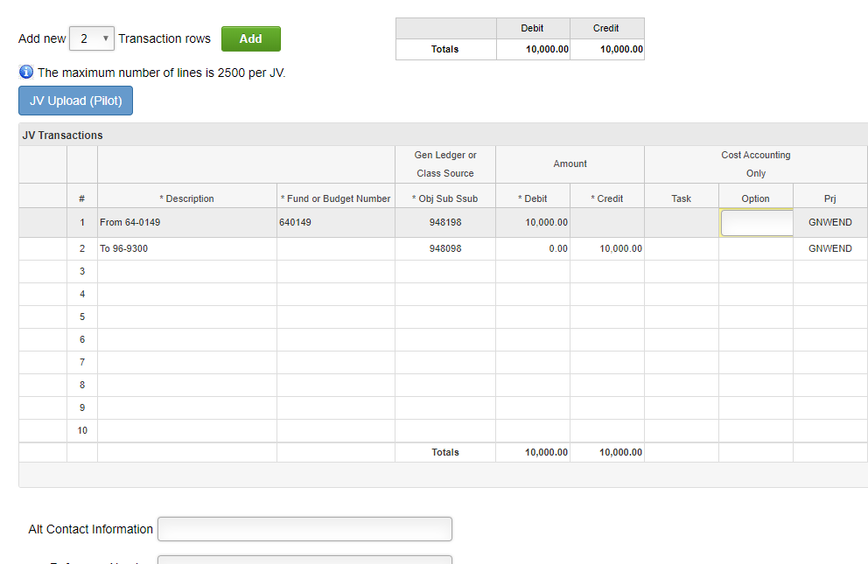
To learn more about submitting Journal Voucher in MyFinancial Desktop, please go to https://finance.uw.edu/myfd/eLearning/journalvoucher.
After submitting a Journal Voucher online, please email Vivianne Yang (vivianne.yang@uw.edu) the details of the reinvestment, so that she can move funds from 96-9300 to each endowment while preparing purchasing. Any transfer requests received before purchasing date (1/1, 4/1, 7/1, and 10/1) will be processed in the following quarter.
If you have any question, please email Robert Bradshaw (robertcb@uw.edu) or Vivianne Yang (vivianne@uw.edu) at Treasury Operation.

